Last Updated: 3/11/2021
NAME
Boonslick Community Development Corporation (i.e. BCDC)INDUSTRY/SECTOR
Non-Profit
WHAT WE DO/TARGET AUDIENCE
Our focus is on economic development and our primary prospect is anyone looking for information on how to open a business in the Cooper county (Missouri) area. Prospective companies are most interested in our accessibility to major resources in transportation, workforce, education/workforce development, and a strategic location. In addition, what is the community like.
PREFERRED COLORS
Prefer blue tone. Including three images on pages 2-4 that contain a starting point for a possible color palate for incorporation into the logo which involve about 4 main colors.
IDEAS/”WANTS” OR CONCEPTS FOR THE LOGO
- Our long name will need to be spelled out as part of the logo - Boonslick Community Development Corporation. Should be easily legible unlike the example cursive-looking header on the images from page 3 and 4.
- Would like to identify that we are in the State of Missouri (centrally located). Important aspect as it gives person a sense of place/locale
- We are near water, rail, and a major United States interstate (I-70) which is a plus in this realm.
- Draft of a web site outline/wire frame is on page 5 to give an idea of the information we will provide on the site
- If we had to pick between item 2 and item 3, item 2 is priority.
- Will the final version translate well to printed/hard copy materials that are in color or black/white
- Words that describe our service area could be:
  - Rural
  - Historic
  - Agriculture
  - “Rolling Hills” terrain
  - Mainstream amenities
    - Casino
    - Multiple fast-food options
    - Wal-Mart
    - Hi-speed internet options (business AND residential)
    - Multiple parks and recreation facilities including a YMCA
  - Other - https://goboonville.com/

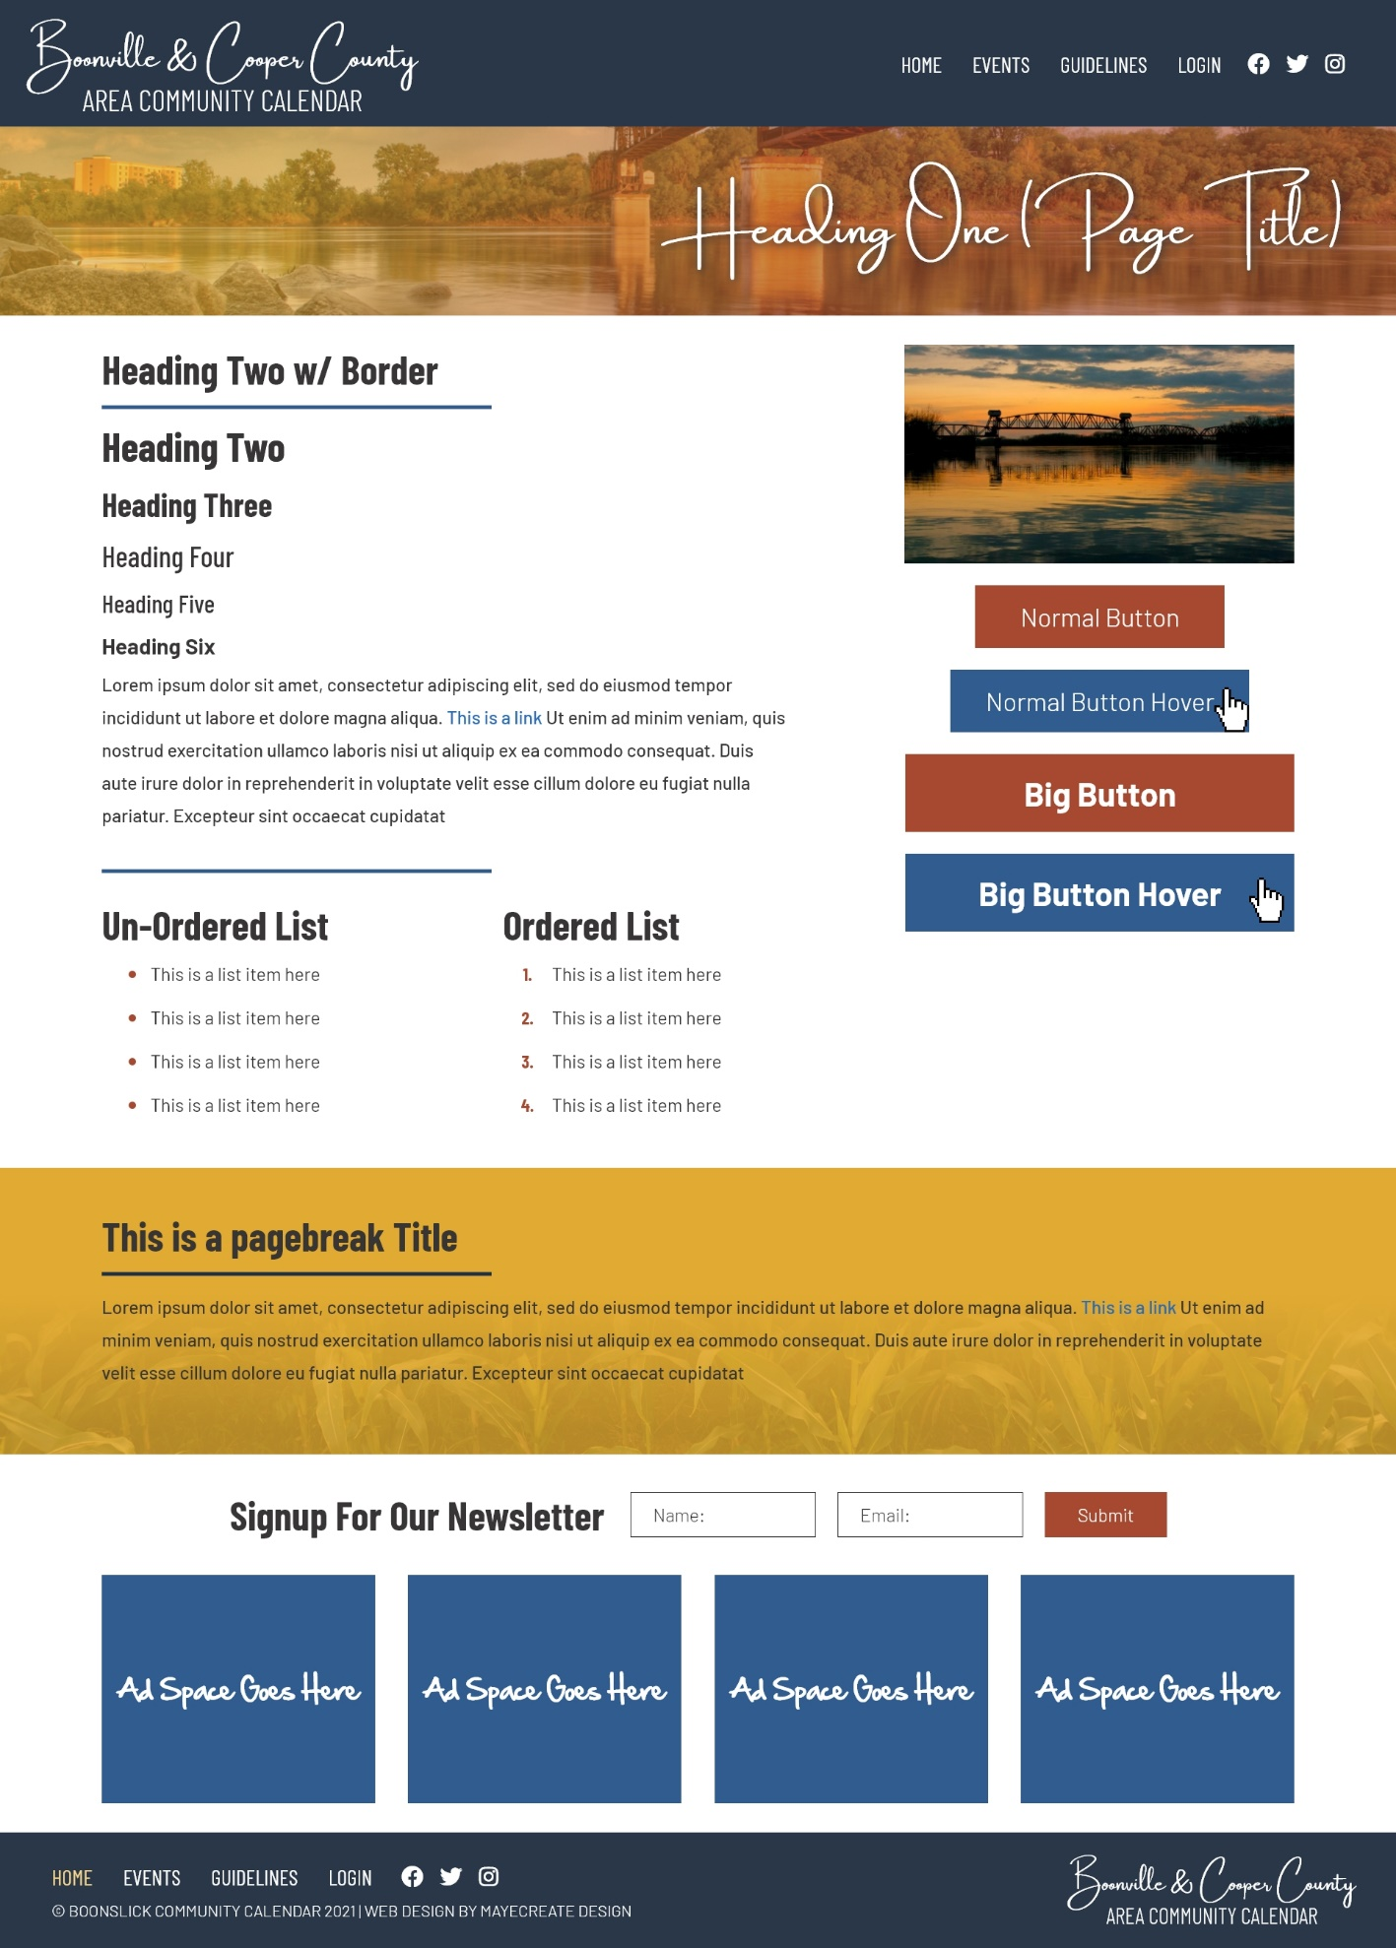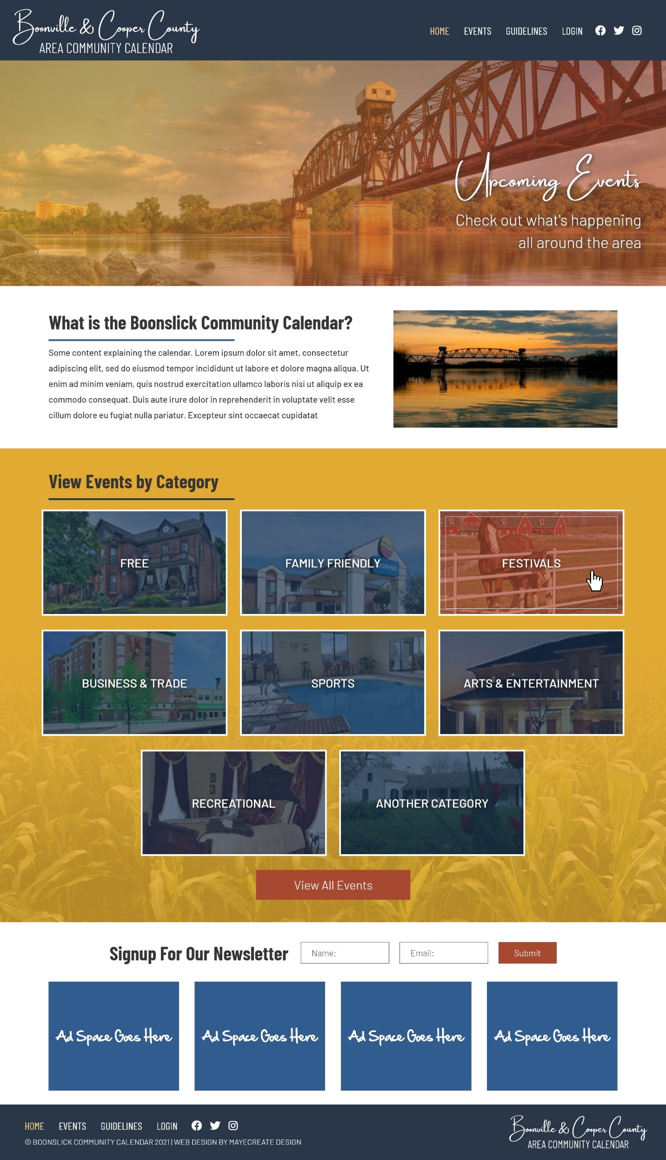
Draft Web Site Outline
