Overall: I like contrasts in font type (like below) or in shading. Prefer clean lines to separate the image from words, or between blocks of words. Gravitate towards abstract images.

As I think about what I want Anthos Consulting Group to represent, it would be growth, ability to flourish and movement; allowing brands, ideas and ultimately people shine; providing clients with clarity on their brand, what they offer customers and how they communicate

I registered the company as Anthos Consulting Group LLC. Not sure how much flexibility I have to change the logo name. We can explore variations of this like Anthos Consulting, Anthos Global along with a tagline. Do you have any suggestions on how to handle the logo vs. registered name?
______________________________________________________________________________

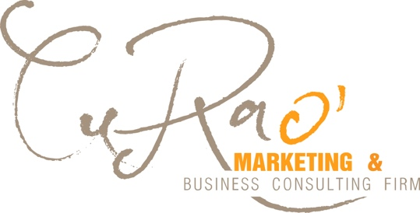

I like the contrast and that this incorporates different font types (cursive and clean, block letters). It may be slightly too feminine, but it would be nice to explore
______________________________________________________________________________
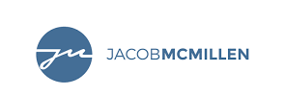

Or something like this. Would even like a line below with space for a tagline.
______________________________________________________________________________

I really like the subtle link to the leaf and how it’s in the background. Growth Marketing, or something like that, would be interesting to include so they understand the connection. Not wild about this font or colors.
______________________________________________________________________________
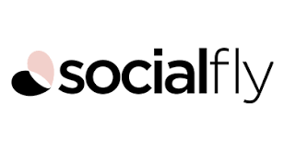
I like the overall look here

______________________________________________________________________________

Appreciate the contrast and use of line and how it looks clean. Don’t like the symbol and it feels a little plain…

______________________________________________________________________________

I like the clean font and overall look
______________________________________________________________________________

I like how there’s some movement and connection to other letters. Maybe there could be connection to different words?
______________________________________________________________________________

ANTHOS CONSULTING
Cultivating brands and ideas

Anthos CONSULTING
Cultivating brands and ideas

