Logo tournament guidelines/inspiration
- The differentiation of Burdock Naturals is the following: natural cures for common skin problems. We need to ensure that our logo highlights this differentiation while still appealing to our male target market. Our primary product is a soap bar that cures these skin problems:
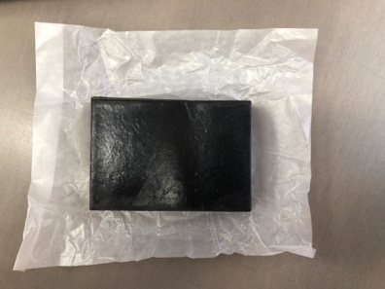
- The product itself (shown above) is a very dark brown, nearly black. The burdock root is an earthy beige, and the leaves are green. These three colors make a great color scheme. The roots/leaves capture an earthy natural element without alienating our male target market. The black soap bar itself is cool and sleek.
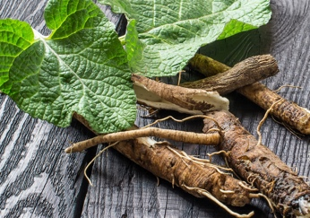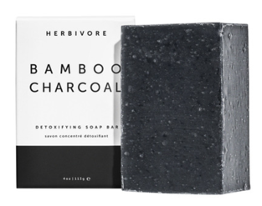
- The full “Burdock Naturals” logo will be placed on a wood box that looks like this:
- Duke Cannon is another brando to look at for inspiration. They engrave their soap bars like the following (below). We would want to do the same, except with “BN” and an appropriately related engraving.
