About AYA Inspired:

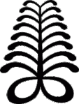

What is AYA?
The Aya Symbol:
- The Aya symbol was originally created as one of many symbols by the Akan of Ghana in West Africa to represent concepts or original thoughts. These symbols could be used to create messages and represent parts of life.

The Aya symbol represents a “fern.” The fern is a hardy plant that can grow in difficult places. It can withstand dry soil, diverse weather conditions and became to represent human perseverance in life.

This symbol, like the fern, represents defiance, hardiness, resiliency, endurance and resourcefulness.

An individual who wears this symbol suggests that she has endured many adversities and outlasted much difficulty. (Willis, The Adrinkra Dictionary)

Dauntless and courage are symbolized by this sign.

It indicates the will to persist even when adverse circumstances make it difficult.

Towards the top of the symbol, the obtrusive influences get smaller. This means that when one continues on her chosen path without wavering, the difficulties will diminish as well.

The Aya Name:
- Aya (あや, アヤ) is a common female Japanese given name meaning colorful or beautiful.
- Aya in the Hebrew language means to fly swiftly or bird.
- Aya is also an Arabic feminine name written as آية meaning wonderful, amazing or miracle.
- In Mongolian, similar to Turkish, it means goodness, music and melody.
- To a tribe known as Yoruba in Nigeria, Aya also means wife.
- The word's origin comes from Proto-Tibeto-Burman ’ay (alternate form yay) meaning mother.
- Aya (or Aja) in Akkadian mythology was a mother goddess, consort of the sun god Shamash. She developed from the Sumerian goddess Šherida, consort of Utu.
- In Turkish-Altaic mythology, Aya symbolizes the good soul. All the seventeen types of benevolent angels who live in the sky are also called Ayas. They are seen as the source of abundance and creativity.
-Wikipedia AYA, Adrinka Dictionary, Adrinka symbols of West Africa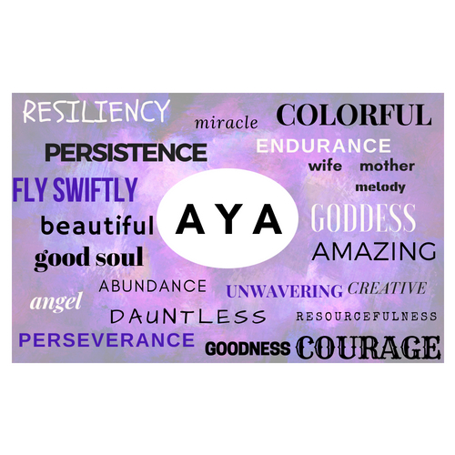
To be “Inspired” by both the word and symbol of AYA would look like this:
What AYA means to me:
- I first encountered the Aya symbol at one of the most critical points in my life. At age 38, I had just been diagnosed with advanced stage 3 cancer and was about to begin an extremely aggressive, body and soul destroying battle with eradicating the cancer using one of the most toxic biochemotherapy regimens available for treatment. My life and everything I had ever known was on the line. Aya, the fern and everything it stood for become MY symbol, MY inspiration and gave ME the will to fight on even the hardest and most desperate of days.
- In the last 5 years, I have endured a reoccurrence of the cancer, another round of treatment, experienced numerous and chronic health conditions from cancer treatments and so many ups and downs it is hard to keep track.
- Aya has continued to inspire me to live my best life, no matter the obstacles. To be present. Persistent. Have courage. Be a good person and good soul. Know that I am a beautiful goddess. A mother, wife and a miracle. Angels surround me and guide me as I go. My resourcefulness and persistence will know no boundaries. I will fly swiftly and with ease. I will experience abundance. I AM an individual who has endured many adversities and outlasted much difficulty. I am AYA. I wish to live an AYA Inspired Life and I want to share that with others.
AYA Inspired is born:
- I have always dreamed of becoming an entrepreneur and AYA Inspired has been whispering to me in my consciousness for a long time. Asking and waiting for the right time for my true self to be ready to launch into the greater world and reach others based upon my life experiences, career in conventional medicine and exploration of alternative and integrative health.
- AYA Inspired is a health and wellness site. But more than that, AYA Inspired is a functional medicine or “root-cause” based hub of information on full mind-body health and wellness.
- Using this functional medicine based, integrative health and lifestyle approach to embracing full mind-body wellness will inspire others to achieve their most EMPOWERED, PURPOSEFUL and PASSIONATE life!
- AYA Inspired will focus on 7 key areas for optimal health:
  - Body & Fitness – rest, movement, exercise, physiology, work out guides
  - Food & Nutrition-- recipes, supplements, meal plans, latest research on nutrition
  - Mind & Body Connection—positive mindset, self care, meditation, breath work, manifesting your desires
  - Spirituality—finding your true calling and purpose, prayer, energy work, spiritual connections
  - Personal & Professional Life- hobbies, travel, finances, career development
  - Relationships & Communication—parenting, marriage, friendships, family
  - Physical Enviorment & Lifestyle—home life, gardening, fashion, beauty, design, limiting toxins in home life and physical environment
- In addition, AYA Inspired will regularly offer opportunities to work with Crystal Crowley through one-on-one or group health coaching, online courses, webinars, special events, speaking engagements in order to achieve an even more specialized and individual approach to truly live an AYA Inspired Life.

Indeed, it is time to live AYA Inspired! Come along with me…

