Mass Timber Mixed Use Commercial Building -- Logo Ideas
Current Building Design: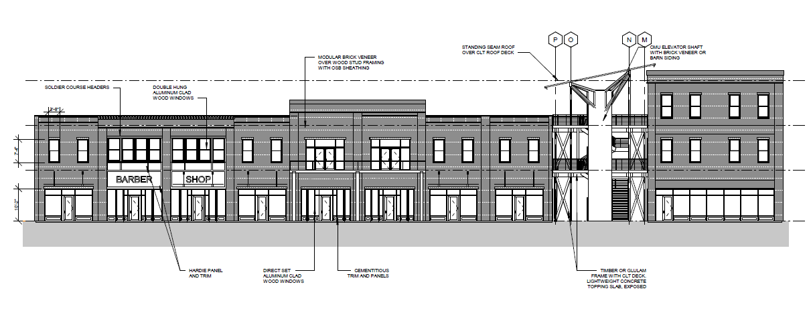
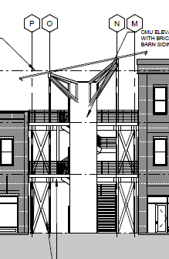 This picture demonstrates the slant in the roof which we would like to possibly immolate in the name of the building. The name of the building will be located on this tower which doubles as the elevator shaft of the building in the center of the atrium. I currently envision the name located vertically on the tower.
Additional Ideas / colors / themes;
